**Applied Programming**

**Quiz # 6**

Registration #: _________________

Q. Perform a Breadth First Search on the following directed graph, starting at vertex C. Clearly label the discovery, back and cross edges:

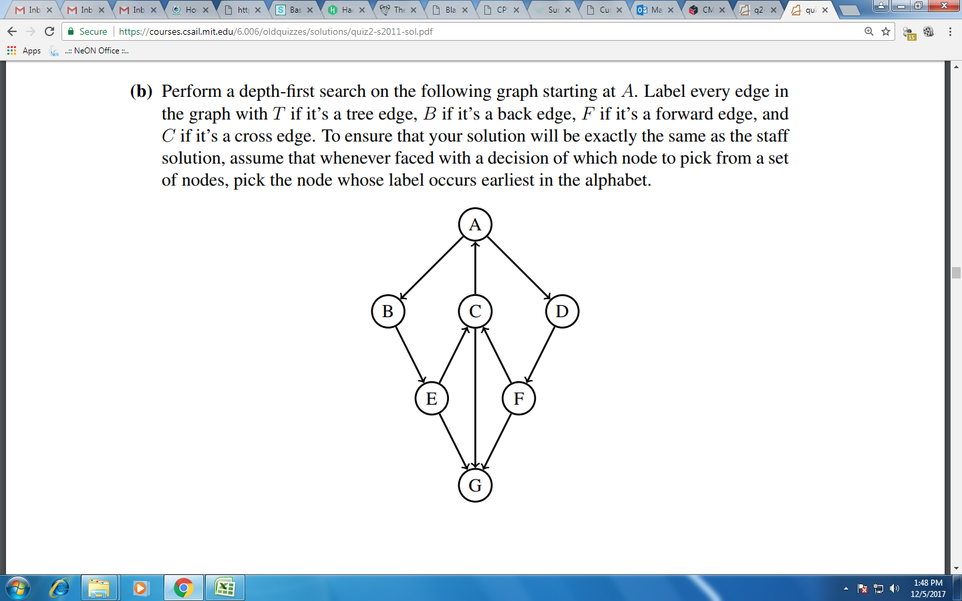

Discovery edges: C->A, C->G, A->B, A->D, B->E, D->F

Cross edges: E->G, F->G

Back edges: E->C, F->C